**Project Design Phase-III**

**Technology Stack (Architecture & Stack)**

|  |  |
| --- | --- |
| Date | 01 November 2023 |
| Team ID | 591-581 |
| Project Name | Travel Insurance Prediction |
| Maximum Marks | 4 Marks |

**Technical Architecture:**

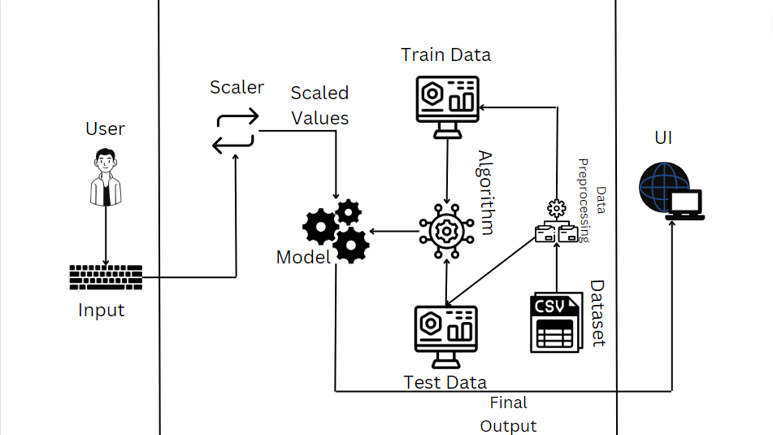

**Example:**

1. The user interface that is used in this project is Web.
2. We had used gradient Booster algorithm in this project.
3. There are no external interfaces (third party API’s etc.)
4. Previous input is shown while typing inputs in the website
5. We had trained the model with gradient booster algorithm.

**Table-1 : Components & Technologies:**

|  |  |  |  |
| --- | --- | --- | --- |
| **S.No** | **Component** | **Description** | **Technology** |
| 1. | User Interface | Web UI | HTML, CSS, JavaScript |
| 2. | Application Logic-1 | Used Gradient Booster in the backend | Python |
| 3. | Database | None | None |
| 4. | External API-2 | None | None |
| 5. | Machine Learning Model | Gradient Booster Model | Gradient Booster model |

**Table-2: Application Characteristics:**

|  |  |  |  |
| --- | --- | --- | --- |
| **S.No** | **Characteristics** | **Description** | **Technology** |
| 1. | Open-Source Frameworks | Flask | Python |
| 2. | Security Implementations | In order to handle high values these high values are converted into scaled values. | Min-Max Scalar. |
| 3. | Availability | Load Balancers are not used. | None |
| 4. | Performance | Can handle multiple requests per second, uses very small amount of cache. | None |